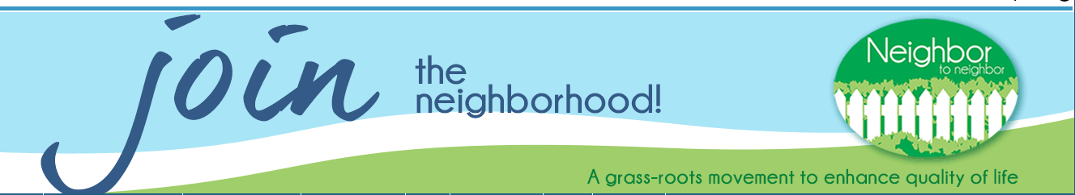
How it works:
MEMBER contacts SERVICE COORDINATOR to make SERVICE REQUEST
By phone: 877-354-8262, ext. 0 and leave a message. To cancel or change a request use ext. 1. Or send an e-mail: ucn2nohio@gmail.com
SERVICE COORDINATOR will respond within two business days to confirm service request was received.
SERVICE COORDINATOR will enter the service request into our database, the Helpful Village system and send notification to prospective volunteers. VOLUNTEERS should check e-mails regularly and/or log into the website to view open requests.
VOLUNTEER will accept the service request online AND notify the MEMBER within 24 hours.
Once a request is taken by a volunteer it will no longer show up as an open request within the Helpful Village System.
If no VOLUNTEER accepts the service request 24 hours before the requested service, the SERVICE COORDINATOR will notify the MEMBER that UCN2N is not able to fulfil the requested service.
After providing the requested service, the VOLUNTEER confirms to the SERVICE COORDINATOR that the service request was fulfilled and lets the coordinator know of any issues. (E-mail and phone contacts above)
The MEMBER may also contact the SERVICE COORDINATOR if there are any issues or comments after the request is fulfilled.
MEMBERS may receive up to four services each month. A service request that UCN2N is not able to fulfil does NOT count as one of the member’s requested services for that month. This number is also flexible based on the member’s needs.
VOLUNTEERS are asked to provide at least two services each month.

