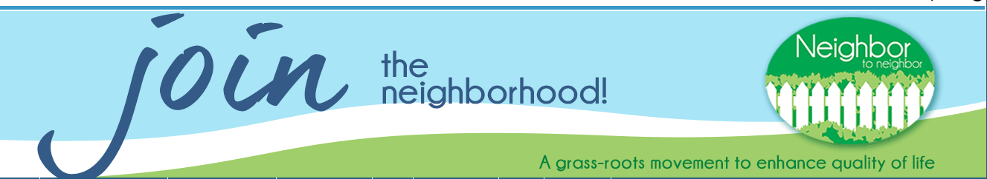

Helpful Village Guide for Volunteers (Selecting Service Requests Using Our Database):

Our website www.ucn2n.org is powered by Helpful Village. Helpful Village is a system that acts as our front-end website, database for member and volunteer information and houses all our service requests.

- Using our website www.ucn2n.org, you will have the ability to browse open service requests, and match yourself with any open service requests that you are available to do. In addition to logging in to the website and viewing services yourself, we will also send you emails with requests. These emails will link directly to the website for you to view in their entirety and select.

- Before you can access the service requests you will need to log in to our website. You will receive an email from the Helpful Village System once you are fully vetted asking you to reset your password. The password reset DOES expire, so if you need us to re-send it again please email ucn2nohio@gmail.com and we are happy to get that res-sent to you.

- Once you are logged in, you can start viewing and signing up for service requests. To do this, go to the Volunteers tab and click on Service Requests. Each service request will have the date, estimated start and end time, member name, type of service and purpose. You can see additional details and sign up for the request by clicking the View button.

- If you are available for the service, click on the button I can do it. I volunteer! You will then see a confirmation message in green. You will also receive a confirmation email. You will see it change from an “open request”, and it will now say “assigned to you.” You do NOT need to do anything in the system after the request is completed.

  - Once the request is over, please email ucn2nohio@gmail.com to confirm the service has been completed. This is especially important if the date or time of the request changed for some reason from the original request.

- Once you sign up, we ask that you call the member within 24 hours to notify them and to confirm details of the request.

- You will only see service requests that match the type of volunteer opportunities you signed up for. (i.e. if you are a volunteer driver, you will see transportation requests).

- In addition to the self-sign up system, we send a weekly email with available requests coming up. The intention of the weekly email is to cut down on the number of emails we send to you. Occasionally, depending on the timing of a request, or if we have trouble filling a request you may get a periodic email with one or two requests.

General Website Information:

- Private vs. Public View:
As volunteers, when you are logged in you will see a different website than if you were not logged in. We call this private vs. public view.

- What you see as a logged in as a volunteer:
  - All the general info that the public can view. This includes; member and volunteer info, testimonials, types of services we do, staff and Board information and you will be able to access all our newsletters.
  - Under the Volunteer Tab:
    - Service Requests-As discussed above. You can view these in several formats including Calendar and List.
    - Service Evaluations -We are not currently utilizing this tab but plan to begin to implement it starting in 2021 (possibly before in a limited capacity).
    - Reporting Hours- If you volunteer for an event or do admin work for us, you can record your hours here. This is not required but will help us in tracking in the future.
  - Events Calendar
- You can view events either way, click on them for more information and to sign up.

